S H A R D H A N
Consultants
SHARDHAN CORPORATE CONSULTANTS LLP
PROCESS DOCUMENT
ACCOUNTING SYSTEM RESTRUCTURING
& BUSY TRANSITION PLAN
GYAN SANSAR
Prepared by: Shardhan Corporate Consultants LLP
August 2026
Private & Confidential

Purpose of this Document
The objective is to start the new BUSY account with a clean structure while also correcting the old records in a controlled manner. This document is intentionally practical: it explains what should be done, and what should not be done.

1. Immediate Action Required
1. Preserve the existing data. Take a complete backup of the present BUSY company and keep one copy unchanged. Old ledgers and vouchers should not be deleted because they may be required for explanation, audit or tax review.
2. Stop creating new informal ledgers. No new ledger should be opened with names such as Suspense, X1, Wallet, DS#, Copy, city suffixes or employee names under Cash.
3. Collect the supporting records. Obtain all business bank statements, POS reports, branch cash sheets, loan statements, supplier and customer balances, GST records, stock details and employee imprest details up to 30 September.
4. Prepare the approved ledger list. The new chart of accounts should be agreed between the Gyan Sansar team and the Shardhan Senior Accountant before it is created in BUSY.
5. Reconcile the important balances first. Banks, loans, cash, POS settlements, suspense balances and the large discount ledgers must be checked before routine renaming work.
6. Decide how April to September will be handled. Since the new account starts in the middle of the financial year, management must choose whether earlier transactions will be rebuilt in the new company or whether verified balances as at 30 September will be carried forward.
7. Test the new company before go-live. Sample sales, purchases, receipts, payments, loan EMIs, branch cash and POS settlements should be entered and reviewed before live work begins.
8. Approve the opening balances. No final opening balance should be loaded without a supporting schedule prepared by the Gyan Sansar team, reviewed by the Shardhan Senior Accountant and approved by management.

2. Ideal Structure of the New Accounting System
1. Capital and personal transactions. Create Capital - Mukesh Sir and Drawings - Mukesh Sir under Capital Account. Personal home-loan EMIs, LIC, personal income tax and transfers to personal savings should be debited to Drawings. Personal bank and home-loan accounts should not be created as business ledgers.
2. Business loans. Create a separate liability ledger for each verified business or vehicle loan, such as ICICI Business Loan A/c - 20227 and Vehicle Loan A/c - XL6 8295. The opening balance must be the principal outstanding and should normally appear as a credit balance.
3. Business bank accounts. Use one consistent name: Bank - Account Type - Last Four Digits - Branch. For example, Canara Bank - CA - 1205 - Patna. Only genuine business bank accounts should be included.
4. POS settlements. Create POS Clearing Settlement A/c under Current Assets. Card sales should first go to this ledger and should be cleared when the bank settlement is received.
5. Cash and employee imprest. Create Main Cash - Patna HO and one Cash - Branch ledger for each approved branch. Money given to employees should be recorded in Imprest A/c - Employee Name, not in a cash wallet.
6. Suppliers and customers. Keep one master ledger for each legal party or GSTIN. Different branches should be identified through branch, cost centre or material centre, not by creating duplicate party ledgers with location names.
7. Sales and purchases. Use Sales - Exempt (Books), Sales - Taxable, Purchases - Exempt (Books) and Purchases - Taxable. HSN and taxability should be set at item level after review.
8. Expenses. Use clear groups such as Employee Benefit Expenses, Selling and Distribution Expenses, Administrative Expenses and Finance Costs. Remove symbols such as # and use understandable names.
9. Suspense and unclear ledgers. Suspense, Suspence and X-series ledgers should not exist in the new system. Each old balance must be identified and moved to the correct account only after review.

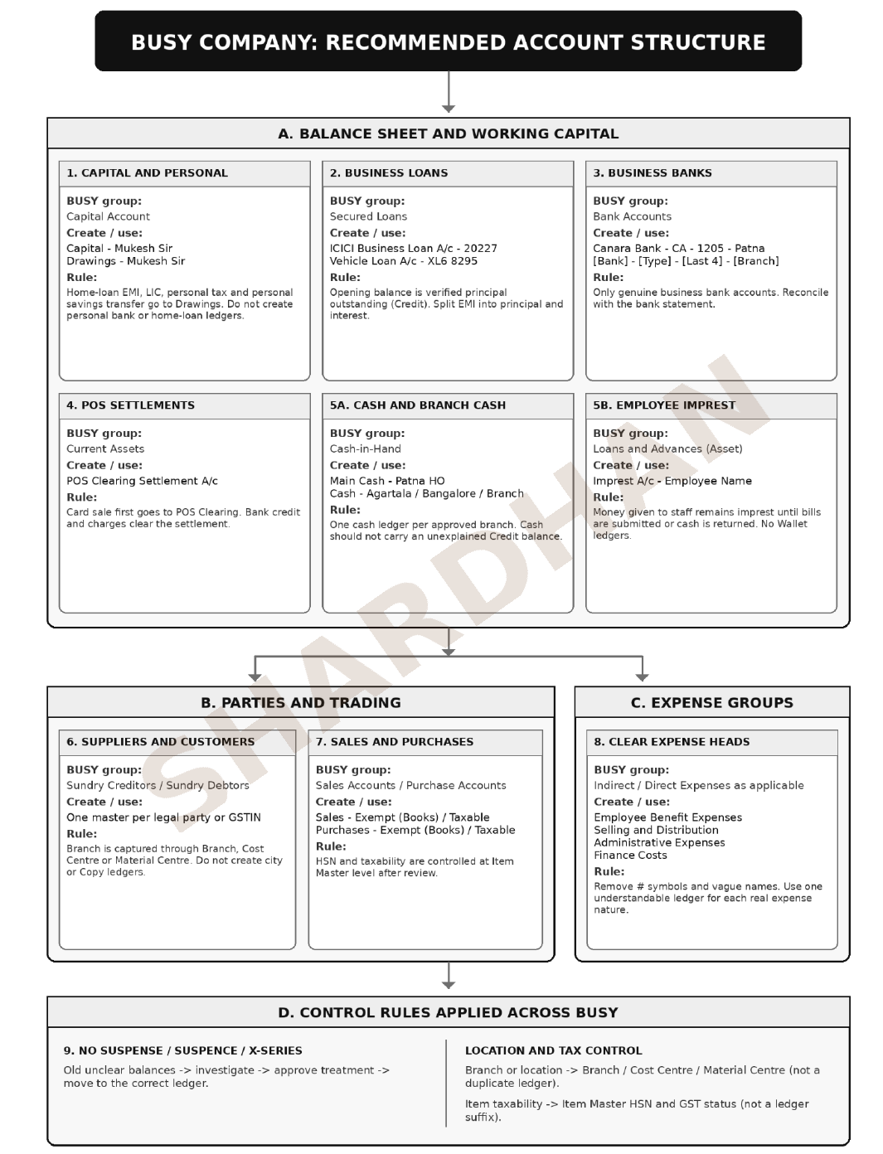

3. Basic Entry Rules in the New System
1. Loan EMI. Debit the loan ledger for the principal portion, debit Interest on Loans for the interest portion and credit the bank for the total payment.
2. Employee advance. Debit the employee imprest when money is given. When bills are submitted, debit the correct expense and credit the imprest.
3. POS settlement. Debit the bank for the net amount received, debit gateway charges where supported and credit POS Clearing for the gross settlement.
4. Branch cash. Record funds sent by head office before recording branch expenditure so that the branch cash ledger does not become negative.
5. Freight and GST. Do not apply 5% reverse charge to every freight payment automatically. First check whether the transporter is a qualifying GTA, whether a consignment note has been issued and whether the supplier is paying GST under forward charge.

4. Process for Cleaning the Previous Data
The clean-up should be performed separately from the daily work in the new company. This prevents old errors from disturbing fresh accounting and allows every correction to remain traceable.
1. Create a clean-up register. List every old ledger, its balance, proposed new ledger, evidence required, person responsible and current status.
2. Review the voucher details. For each doubtful balance, examine the narration, the other side of the entry, bank or cash movement and supporting document.
3. Classify the issue. Decide whether the entry is correct, wrongly grouped, duplicated, personal, unsupported, missing a liability or awaiting management clarification.
4. Prepare the correction. The Gyan Sansar team should prepare the proposed treatment and supporting schedule. The Shardhan Senior Accountant should review it before posting.
5. Obtain approval where required. Management approval is necessary for write-offs, capital or drawings adjustments, large discounts, unsupported balances and entries affecting profit or tax.
6. Pass the approved entry. The narration should mention the clean-up register reference so that the correction can be traced later.
7. Check the result. After each batch, rerun the trial balance, balance sheet, profit and loss account, party ageing, bank reconciliation, cash and loan reports.
8. Freeze the final position. Once the balances as at 30 September are approved, they should be used for migration and the old period should be locked.

5. Important Red Flags Requiring Management Attention
1. Secured Loans showing Rs. 90,16,272.22 Debit. Loan liabilities should normally be credit. Obtain the principal outstanding for every business loan and separate principal from interest. Personal home loans must be excluded from business liabilities.
2. Negative branch cash. Kolkata shows Rs. 11,037 Credit and Kochi shows Rs. 120 Credit. Cash cannot normally be negative. Missing transfers, receipts or expenses paid personally must be identified.
3. Suspense balance of Rs. 4,86,060.41 Credit. This amount must be checked voucher by voucher. It should not automatically be transferred to capital. The actual nature of each item and any tax impact must first be established.
4. Discount Party - Aayush Rs. 18,00,000 and Viveka Rs. 6,00,000. These Rs. 24 lakh balances must not be migrated as discount without invoices, credit notes or a clear written explanation. They may represent bad debts, proprietor withdrawals, receivable corrections or another matter.
5. Duplicate supplier and customer ledgers. Balances and outstanding bills should be combined and reconciled under the correct legal master. The old duplicate masters should be made inactive after review, not deleted with their history.

6. Process for Fresh Entries
1. Use only approved masters. Creation of new account, party and item masters should be restricted to authorised users. If a required master is missing, a request should be reviewed before creation.
2. Enter business and personal items separately. Every personal payment made from a business bank should go to Drawings. It should not be booked as office, loan-interest or other business expense.
3. Record loans from bank schedules. The accountant should use the monthly loan statement or amortisation schedule so that the principal and interest portions are correct.
4. Clear POS settlements regularly. Card receipts should be matched with bank credits and charges each day or within the normal settlement cycle. Old unmatched items should be reported.
5. Close branch cash daily. Each branch should confirm its receipts, payments and closing physical cash. No branch should be allowed to continue with an unexplained credit cash balance.
6. Settle employee imprest promptly. Employees should submit bills or return the unused amount within the agreed time. Long-pending imprest should be reviewed weekly.
7. Use bill-by-bill party accounting. Purchases, payments, sales and receipts should be adjusted against the correct invoice so that debtor and creditor ageing remains reliable.
8. Use branch and cost tags. The location of a transaction should be captured through BUSY branch, cost centre or material centre settings instead of duplicate ledgers.
9. Keep proper evidence and narration. Every material voucher should refer to an invoice, statement, approval or explanation. Narrations such as adjustment or as discussed should be avoided.

7. Regular Controls After Go-Live
1. Daily review. Check bank receipts, POS settlements, branch cash, invoice sequence, missing supporting documents and unauthorised new masters.
2. Weekly review. Check bank reconciliation progress, negative cash, employee imprest, POS ageing, loan entries, duplicate parties and unresolved clean-up items.
3. Monthly review. Complete all bank reconciliations, debtor and creditor ageing, loan principal reconciliation, stock review, payroll and statutory ledgers, GST and TDS reconciliation and management review of the profit and loss account.
4. System controls. Use separate user IDs, restrict voucher deletion and back-dated changes, keep regular backups and lock each month after review.

8. What Should Not Be Done
1. Do not delete historical records. Keep the old company as the reference and audit trail.
2. Do not create a temporary suspense system. A new Suspense, Wallet, DS# or X-series ledger will only carry the old problem forward.
3. Do not pass material adjustments verbally. Write-offs, discounts, capital adjustments and tax-sensitive corrections must be recorded and approved.
4. Do not allow uncontrolled back-dating. Once a month is reviewed and locked, reopening should require written approval.

9. Roles and Working Arrangement
1. Ankit Ji (Accountant). The accountant will maintain daily books, prepare reconciliations and schedules, explain old entries, collect supporting records and implement the treatments agreed during review.
2. Shardhan team. The Shardhan team will design and approve the accounting structure, review difficult accounting treatments, monitor the clean-up register, test the new system and report progress and unresolved risks to management.
3. Shardhan Senior Accountant. A Senior Accountant from the Shardhan team will participate in the important review meetings, verify opening balances and review loan, bank, cash, tax, suspense and large adjustment items.
4. Management. Management will confirm business facts and approve write-offs, proprietor-related adjustments, unsupported balances and matters that could materially affect profit, tax or the balance sheet.
5. Mutual discussion. No important correction or change in the agreed structure will be implemented unilaterally. The Gyan Sansar team and the Shardhan team will discuss the matter and record the final decision.

10. Weekly Involvement of the Shardhan Team
1. Before the visit. The Gyan Sansar team will share the updated trial balance, reconciliations, clean-up register and supporting documents for the items to be discussed.
2. During the visit. The Shardhan team will review completed actions, clear difficult balances, test entries in BUSY, approve mappings and agree the next priority list.
3. After the visit. The Shardhan team will issue a short progress note recording the decisions taken, pending items, responsible person and due date.
4. Escalation. Any material item not resolved within two review cycles will be placed before management for direction.

11. Proposed Implementation Sequence
1. Stage 1: Data protection and collection. Take backups, freeze informal master creation and collect bank, loan, tax, cash, party and stock records.
2. Stage 2: Structure and priority clean-up. Approve the new ledger list and reconcile banks, loans, cash, suspense and large discount balances.
3. Stage 3: BUSY configuration and testing. Create approved masters, configure users and branch features, enter sample vouchers and correct any issues.
4. Stage 4: Opening balance approval. Finalise the 30 September balances and obtain preparation, review and management approval.
5. Stage 5: Go-live and first-month review. Start fresh entries on 1 October, conduct weekly reviews and complete a fully reconciled October closing.
For Shardhan Corporate Consultants LLP
Authorized Signatory

